Duy Nguyen

Design Document

horizontal line

Interactive Cogswell Art Gallery

Overview -

This design document is for *Interactive Cogswell Art Gallery*, a Senior Project for SWE484 by Duy Nguyen. This document contains the High Level Architecture Diagram, the UI Level Design, the Components Document, and the Reusable Components Document.

High Level Architecture Diagram

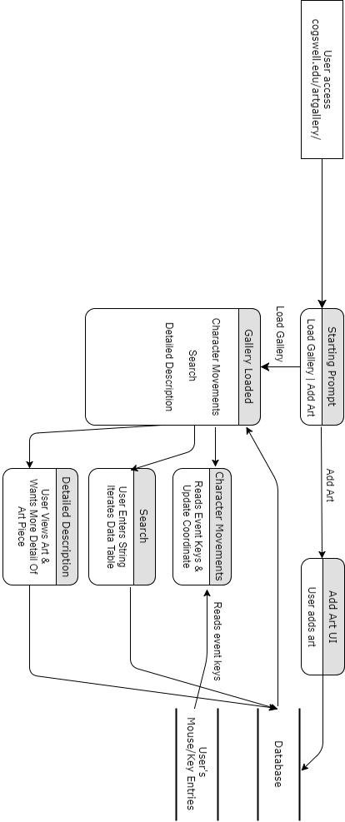

# UI Level Design (Art Upload)

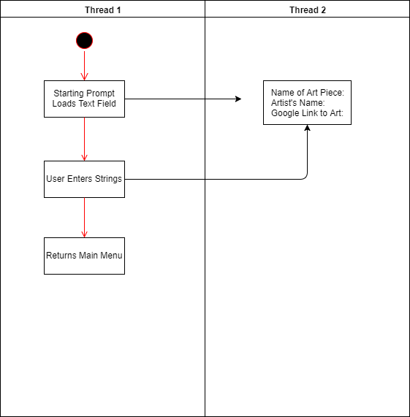

# 

# 

# 

# 

# Components Document

Overview -

* Image Database
* Gallery Subsystem
* Art Upload UI
* User Interaction Subsystem
* Search

**Image Database:**

Relationships:

* Gallery Subsystem pulls data from Image Database.
  + Takes images and 3D models to be displayed at their assigned world coordinate.
* Art Upload UI updates Image Database.
  + Adds images and/or models.
* Search pulls data from Image Database.
  + Pulls data from Image Database in regards to its world coordinate.

**Gallery Subsystem:**

Relationships:

* Character Movement Subsystem updates camera view.
  + X & Y

**Art Upload UI:**

A interface for the user to fill out text fields.

Relationships:

* Art Upload UI updates Image Database.

**User Interaction Subsystem:**

Event keys are registered and monitored. Hitting the arrow key will trigger an increment or decrement to their corresponding directions’ x and y camera coordinates.

Relationships:

* Updates Gallery Subsystem’s camera view.

**Search:**

Interaction:

# Resuable Components Document

**Iteration Access of Database:**

This component handles the iteration access of the database, pulling specific data by other components.

* Gallery Subsystem -
  + Grabs data for the gallery (environment & art pieces)
* Search
  + Access X & Y coordinates of the art piece